# Basic Models

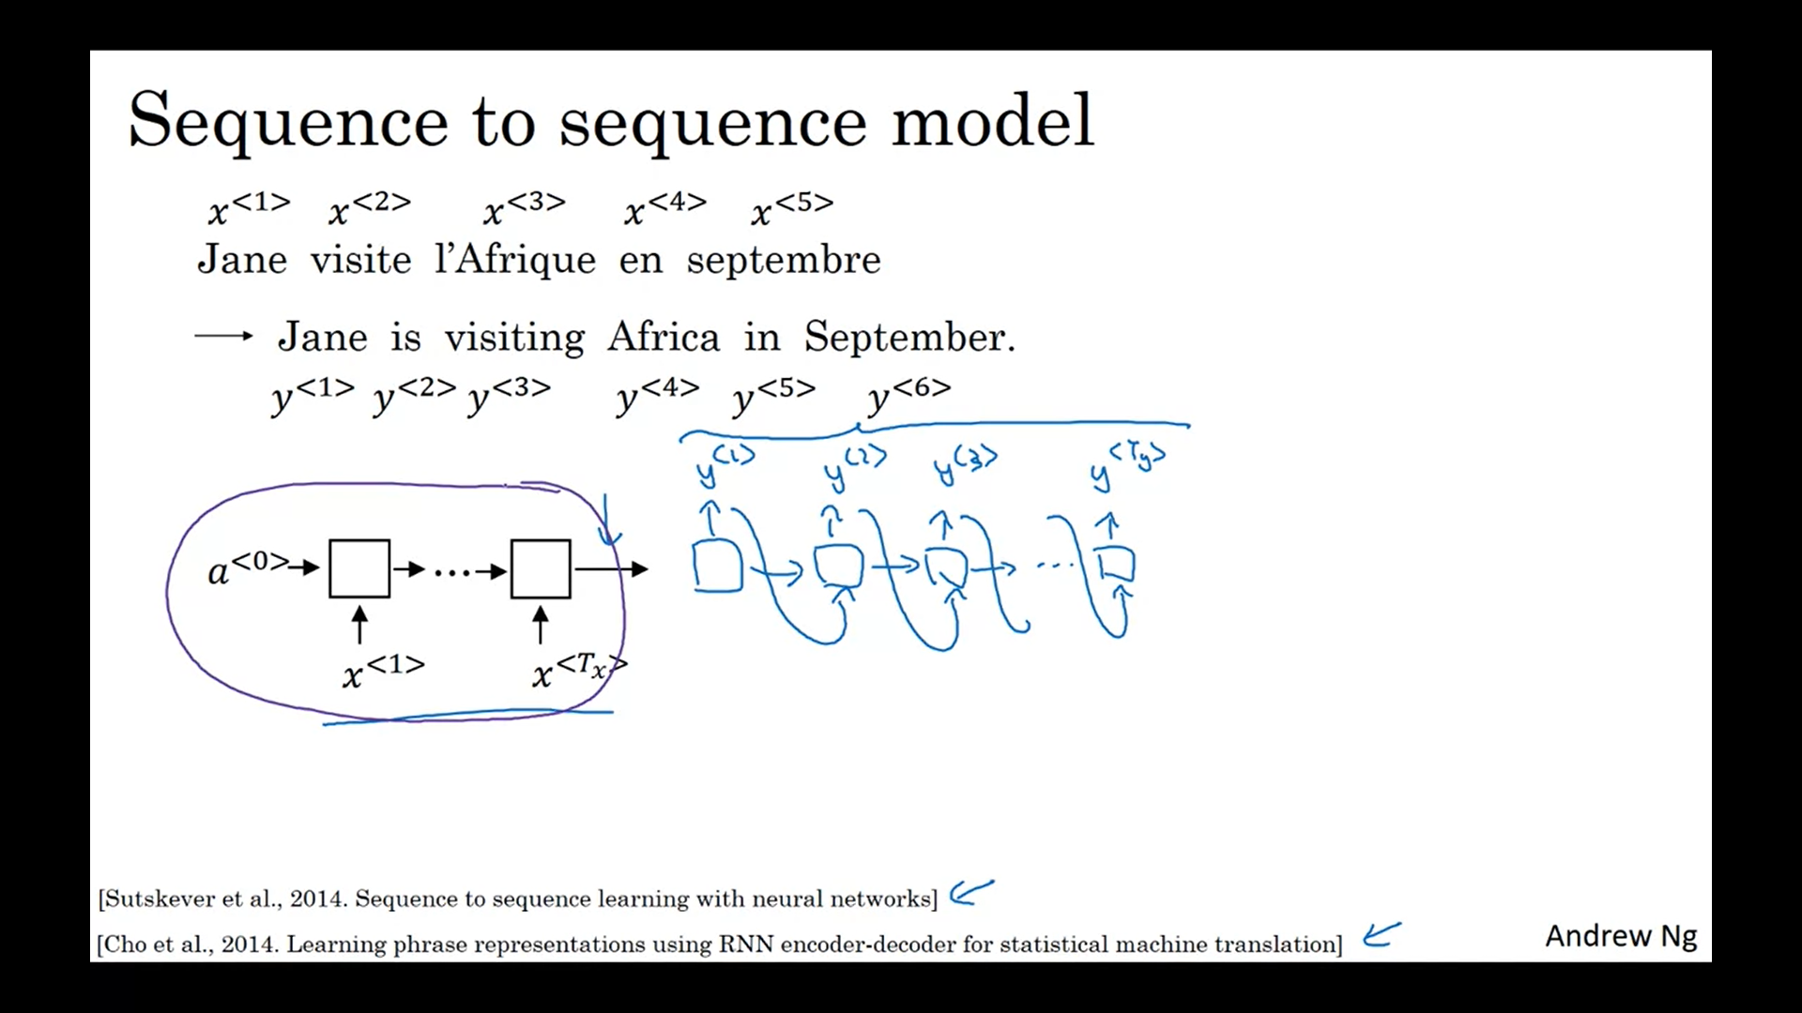

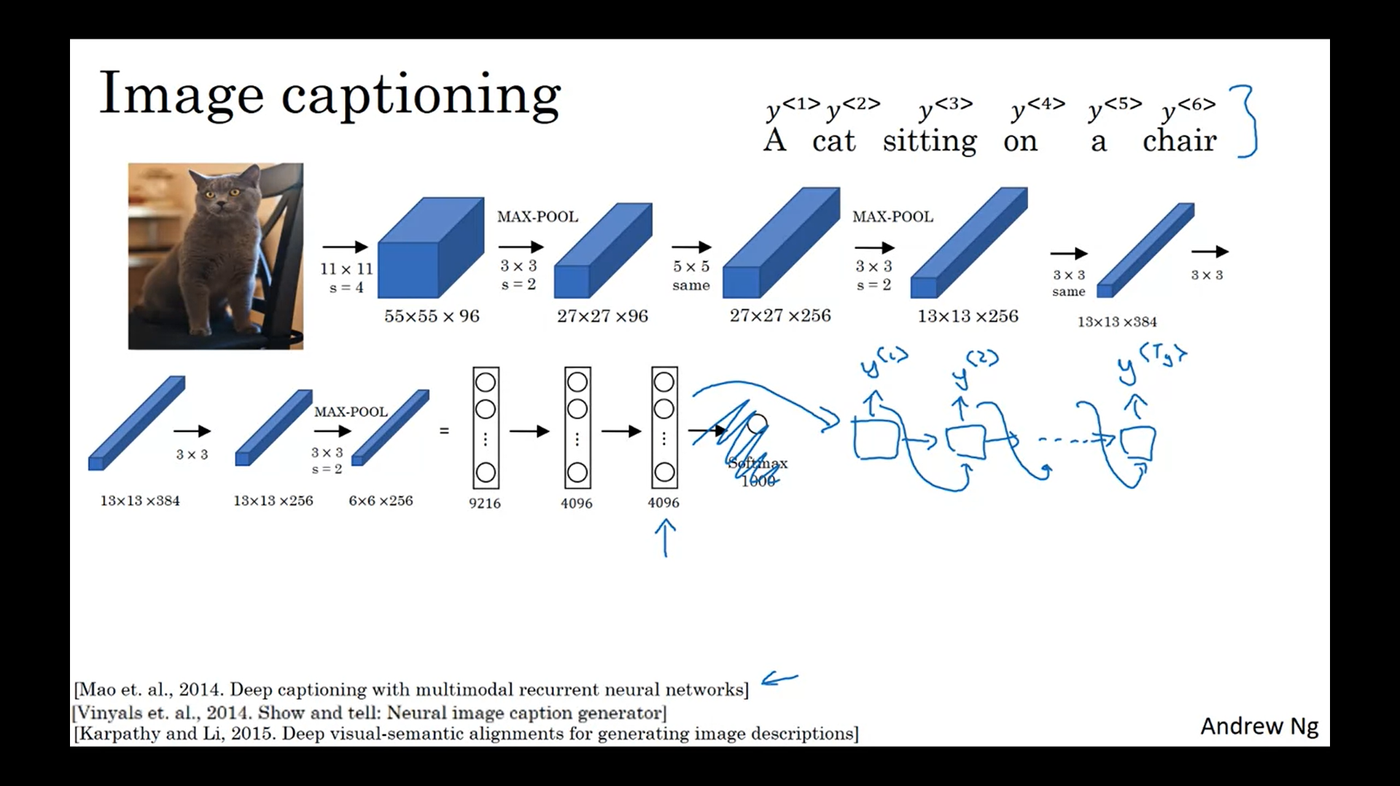

# Picking the most likely sentence

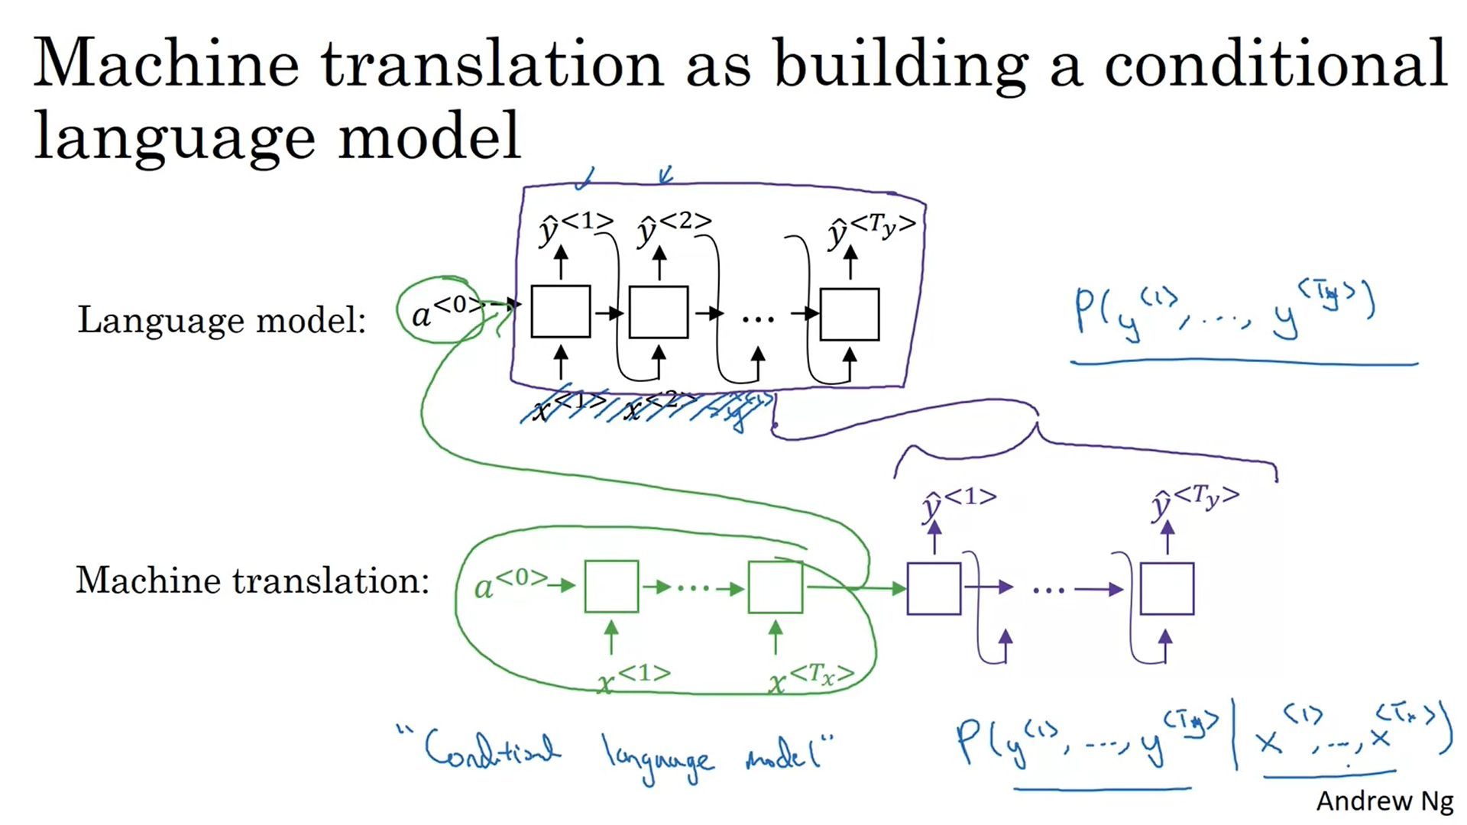

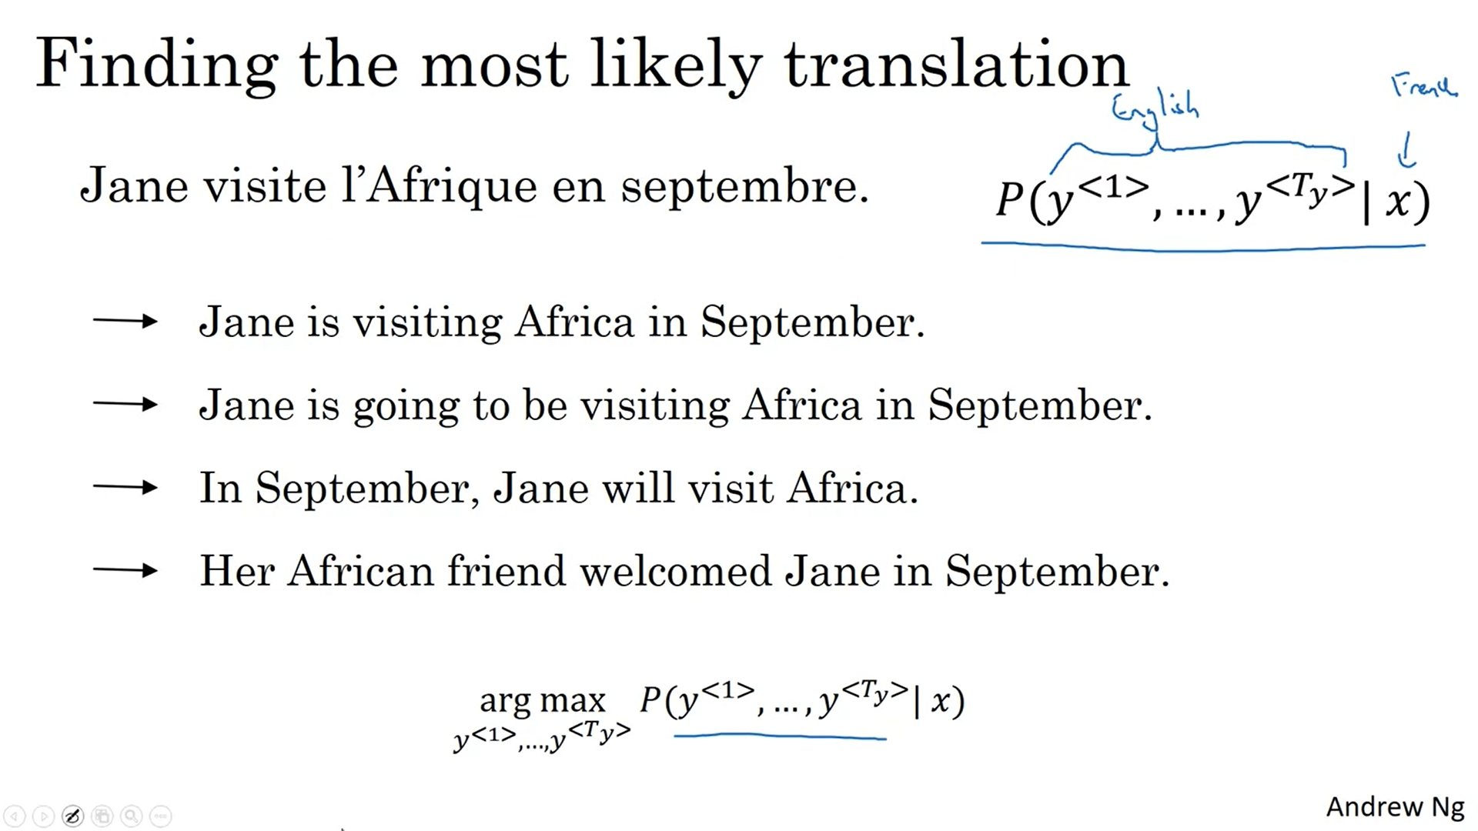

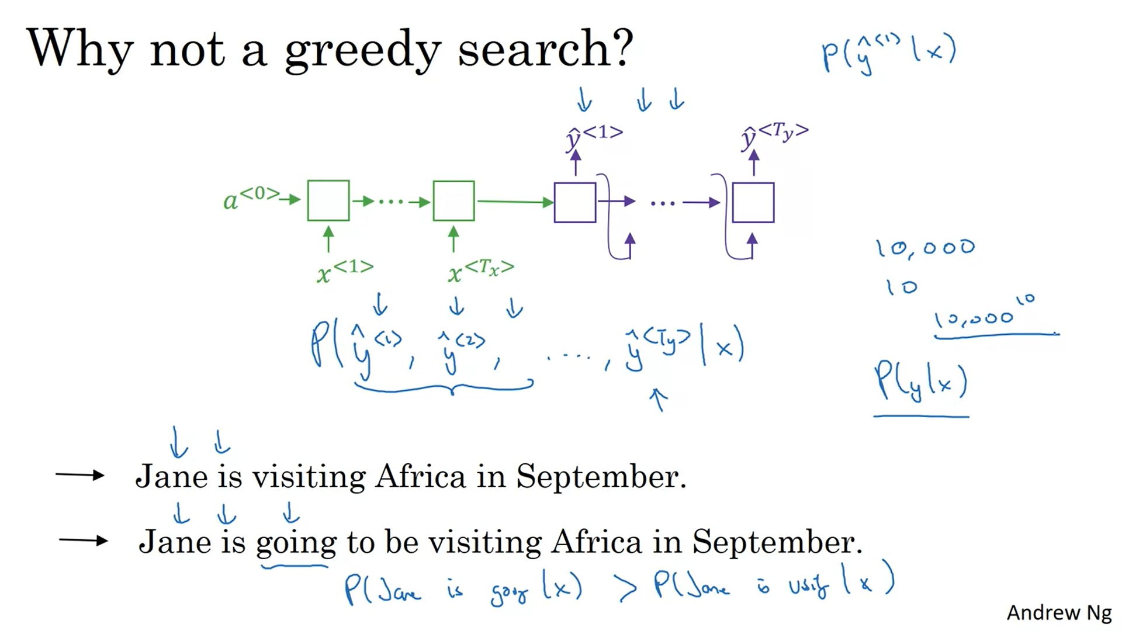

# Beam Search

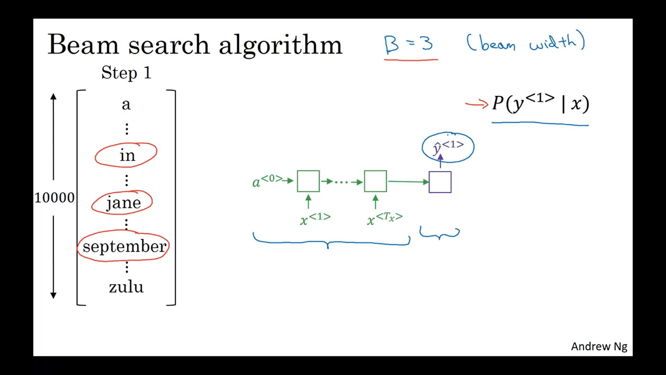

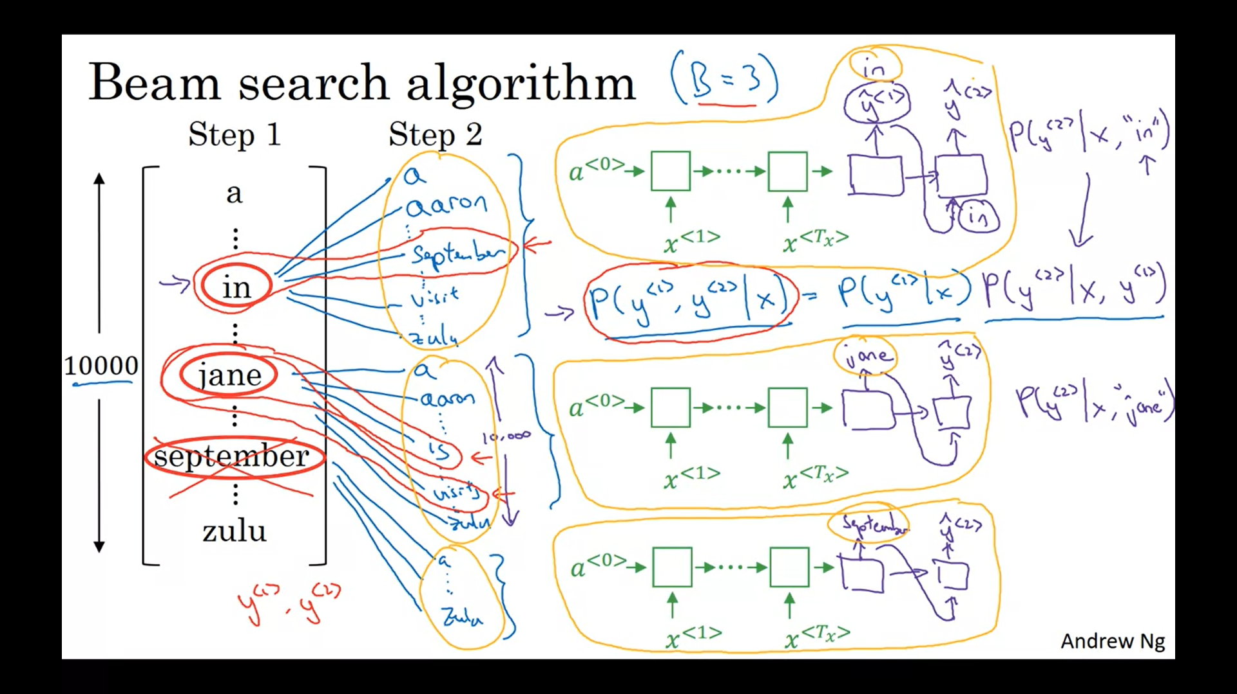

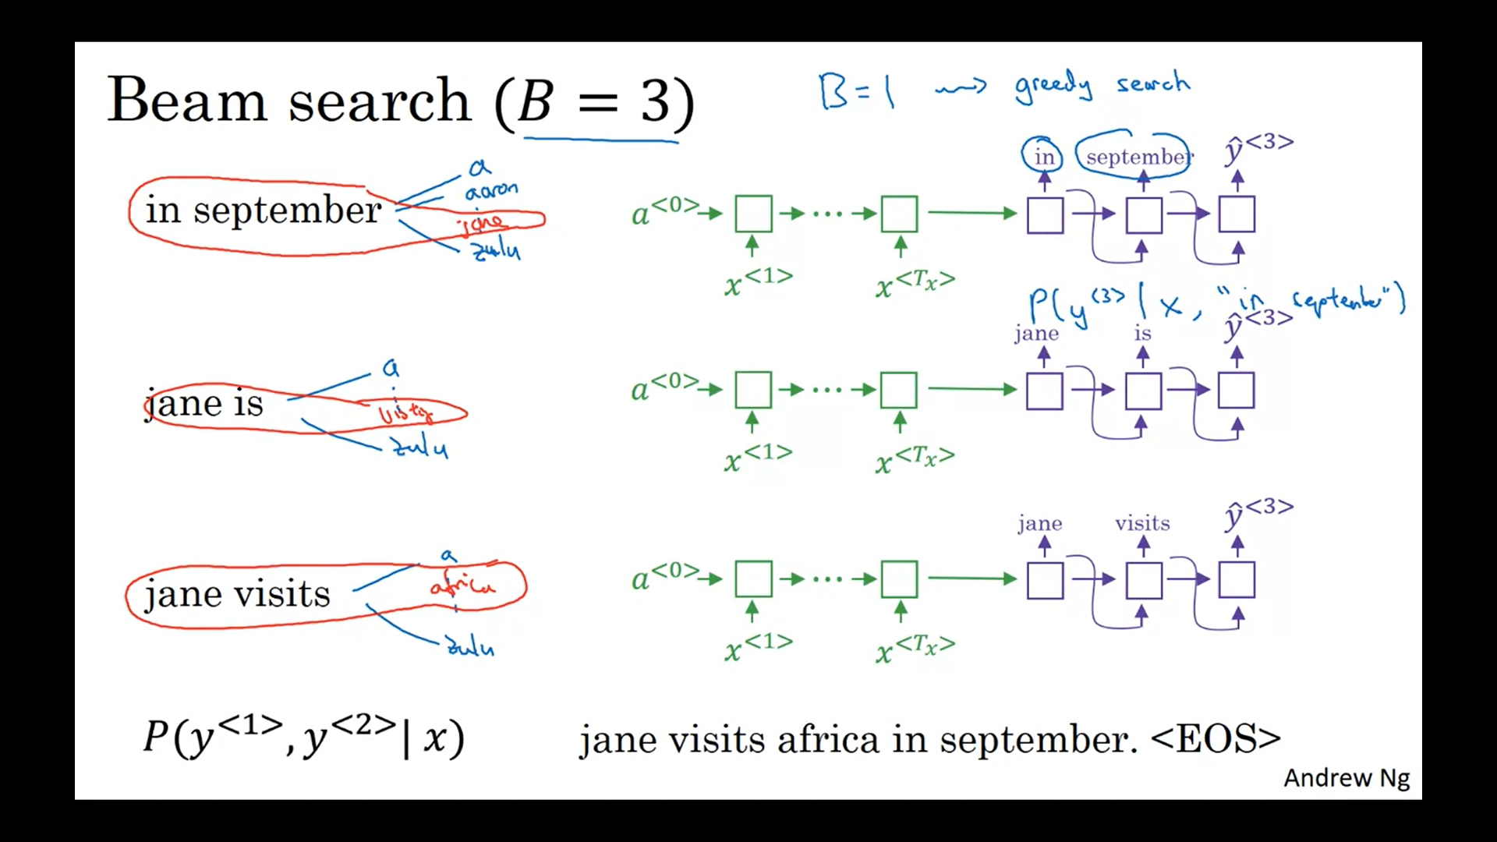

# Refinements to Beam Search

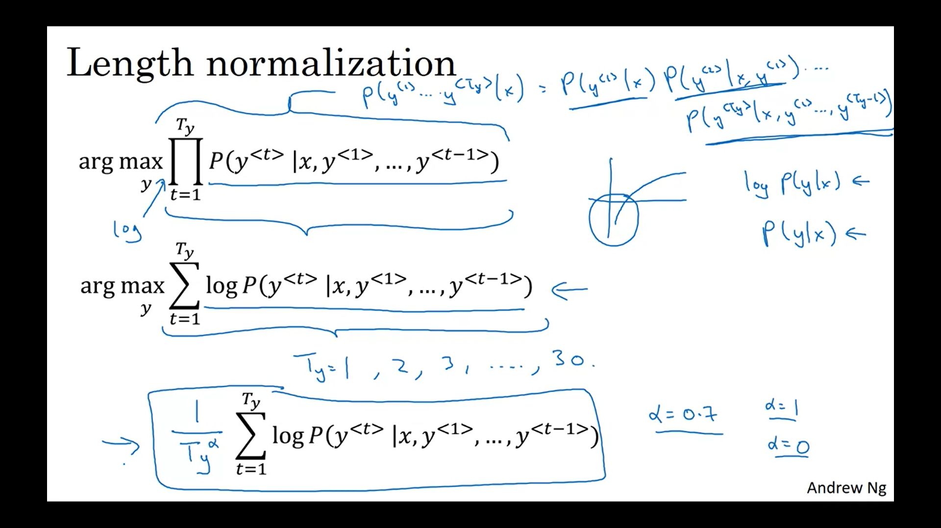

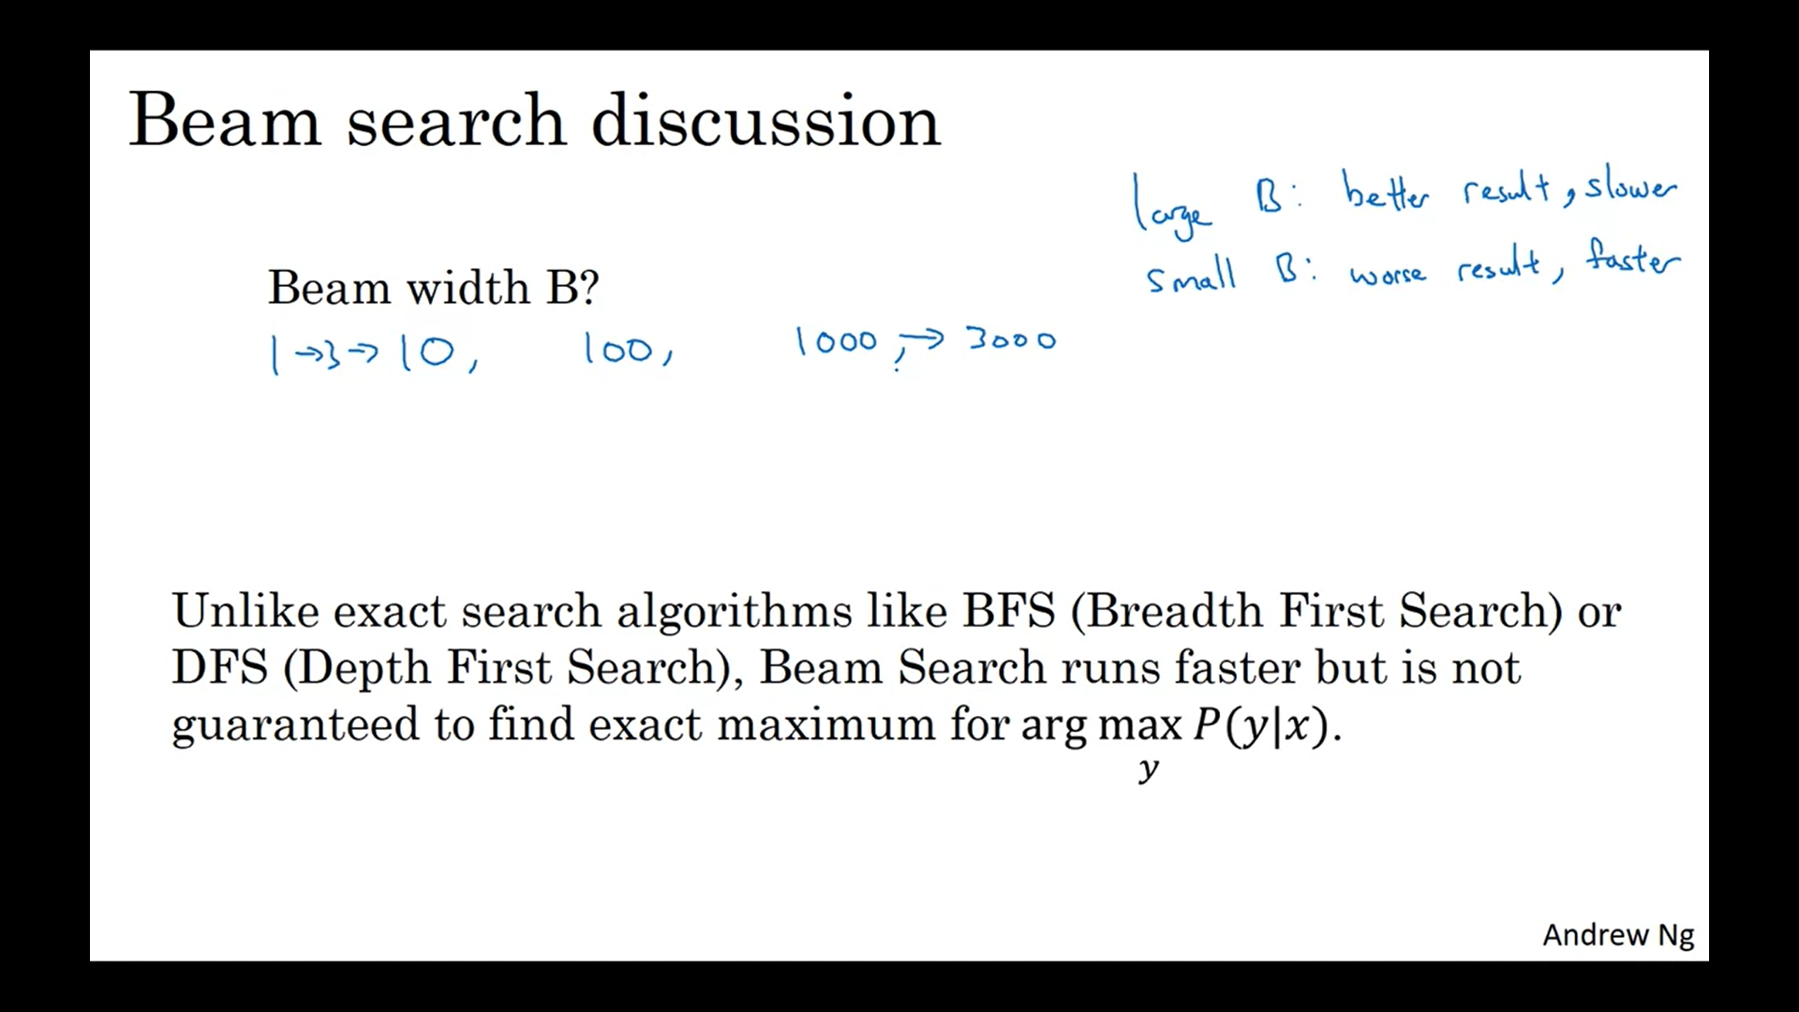

If the beam width is very large,

then you consider a lot of possibilities, and so you tend to get a better result

because you are consuming a lot of different options, but it will be slower.

And the memory requirements will also grow, will also be compositionally slower.

8:08

Whereas if you use a very small beam width, then you get a worse result because

you're just keeping less possibilities in mind as the algorithm is running.

But you get a result faster and the memory requirements will also be lower.

So in the previous video, we used in our running example a beam width of three,

so we're keeping three possibilities in mind.

In practice, that is on the small side.

In production systems, it's not uncommon to see a beam width maybe around 10,

and I think beam width of 100 would be considered very large for

a production system, depending on the application.

But for research systems where people want to squeeze out every last drop of

performance in order to publish the paper with the best possible result.

It's not uncommon to see people use beam widths of 1,000 or 3,000,

but this is very application, that's why it's a domain dependent.

So I would say try other variety of values of B as you work through your application.

But when B gets very large, there is often diminishing returns.

# Error analysis in beam search

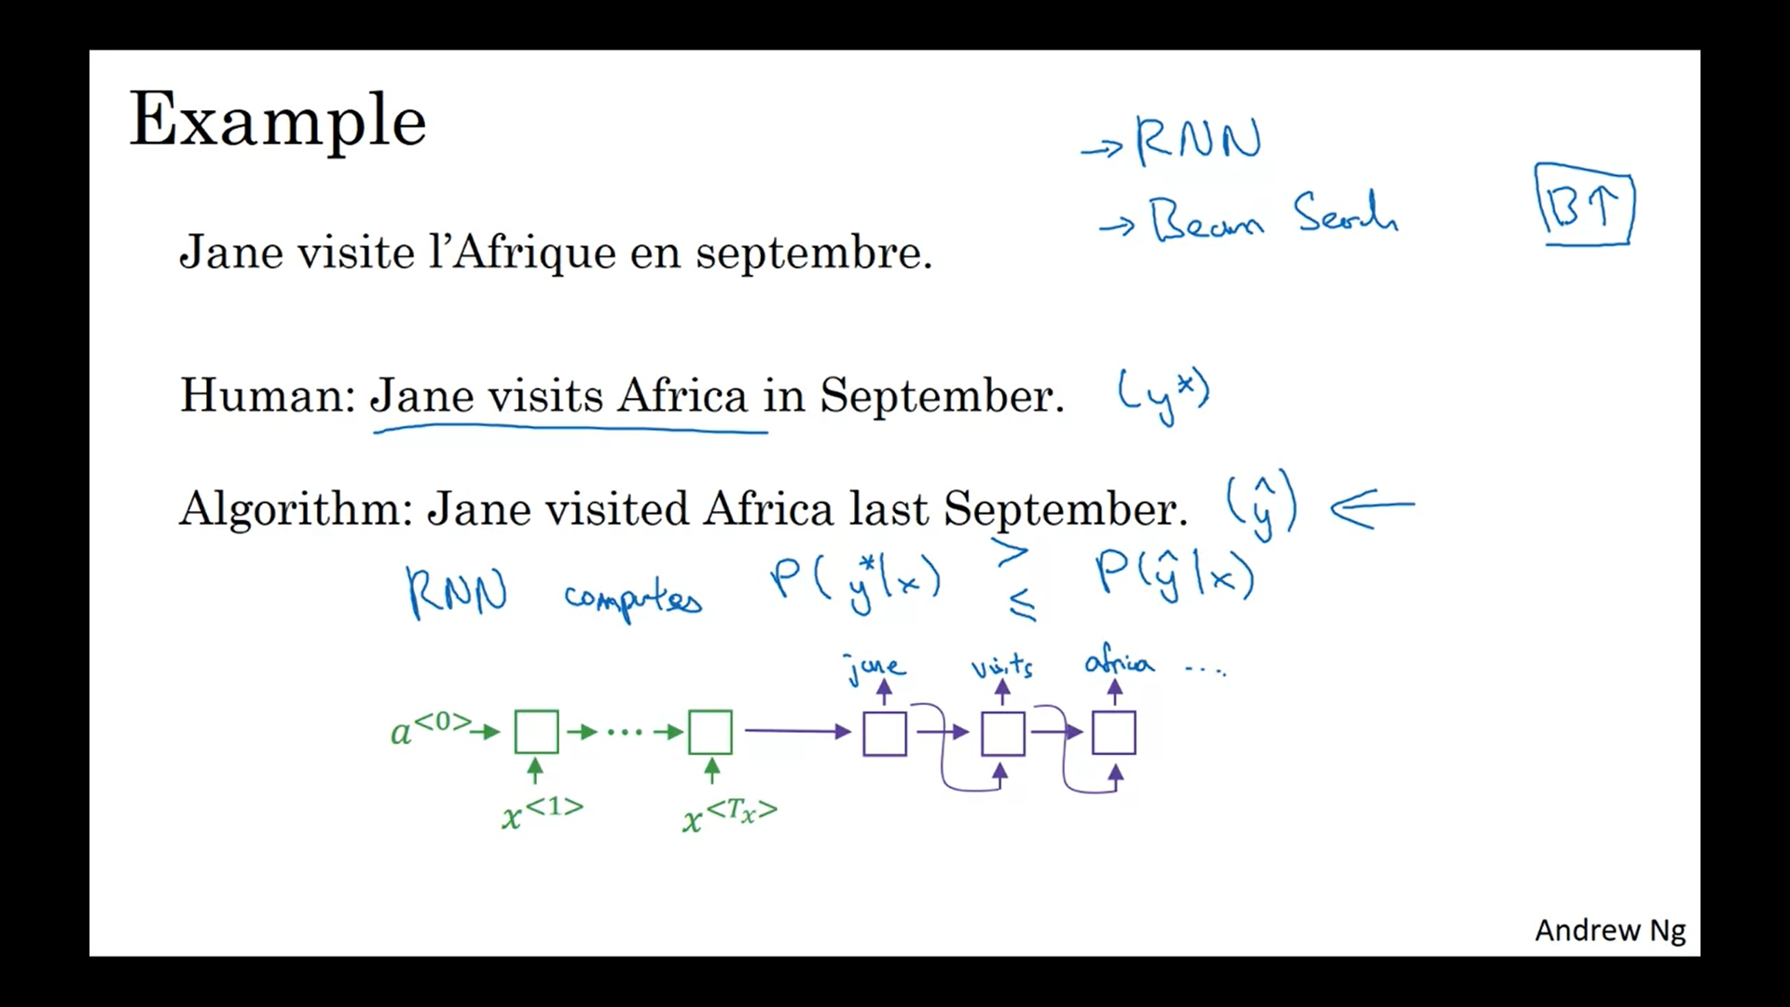

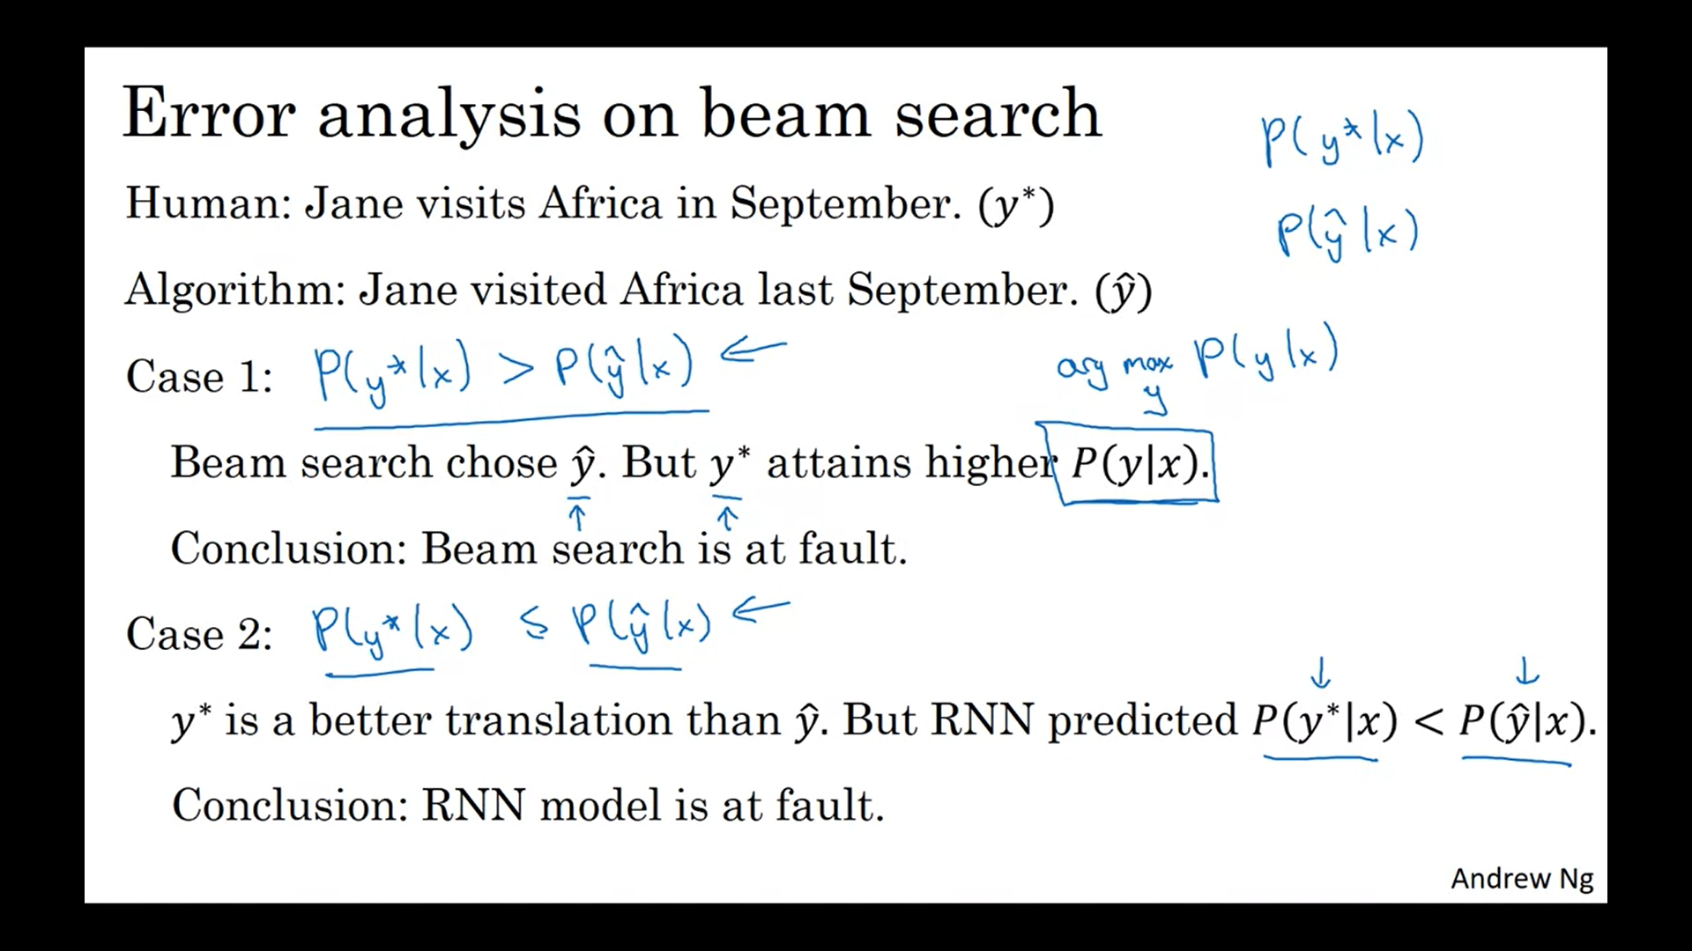

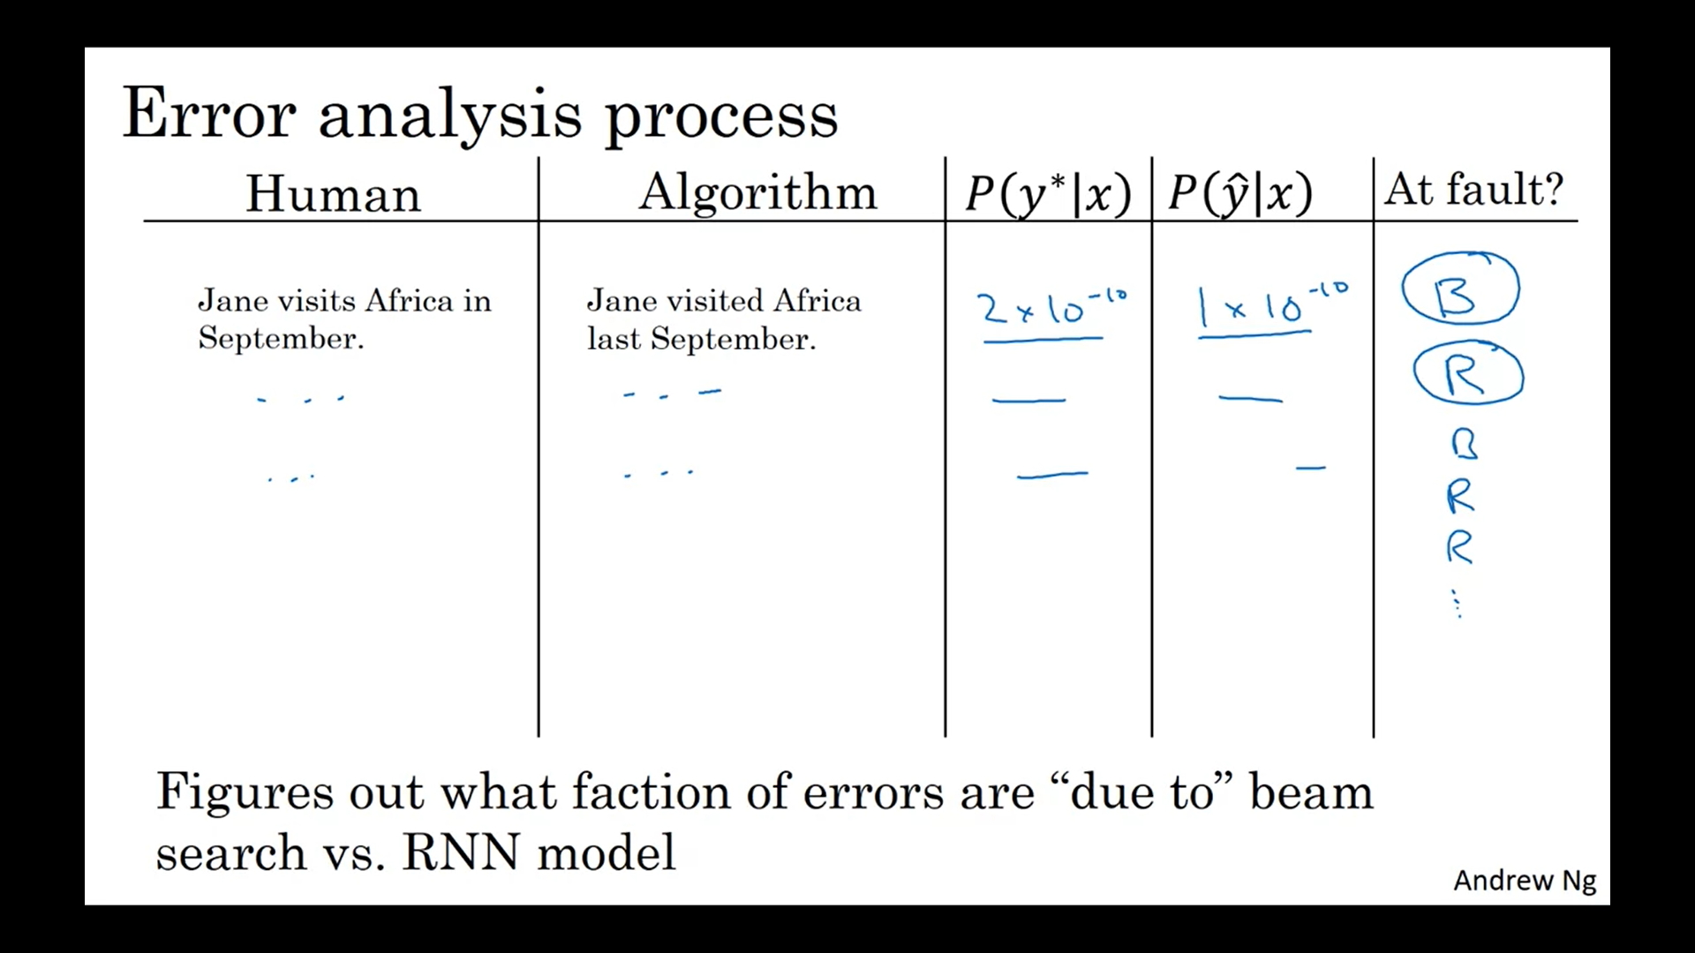

# Bleu Score

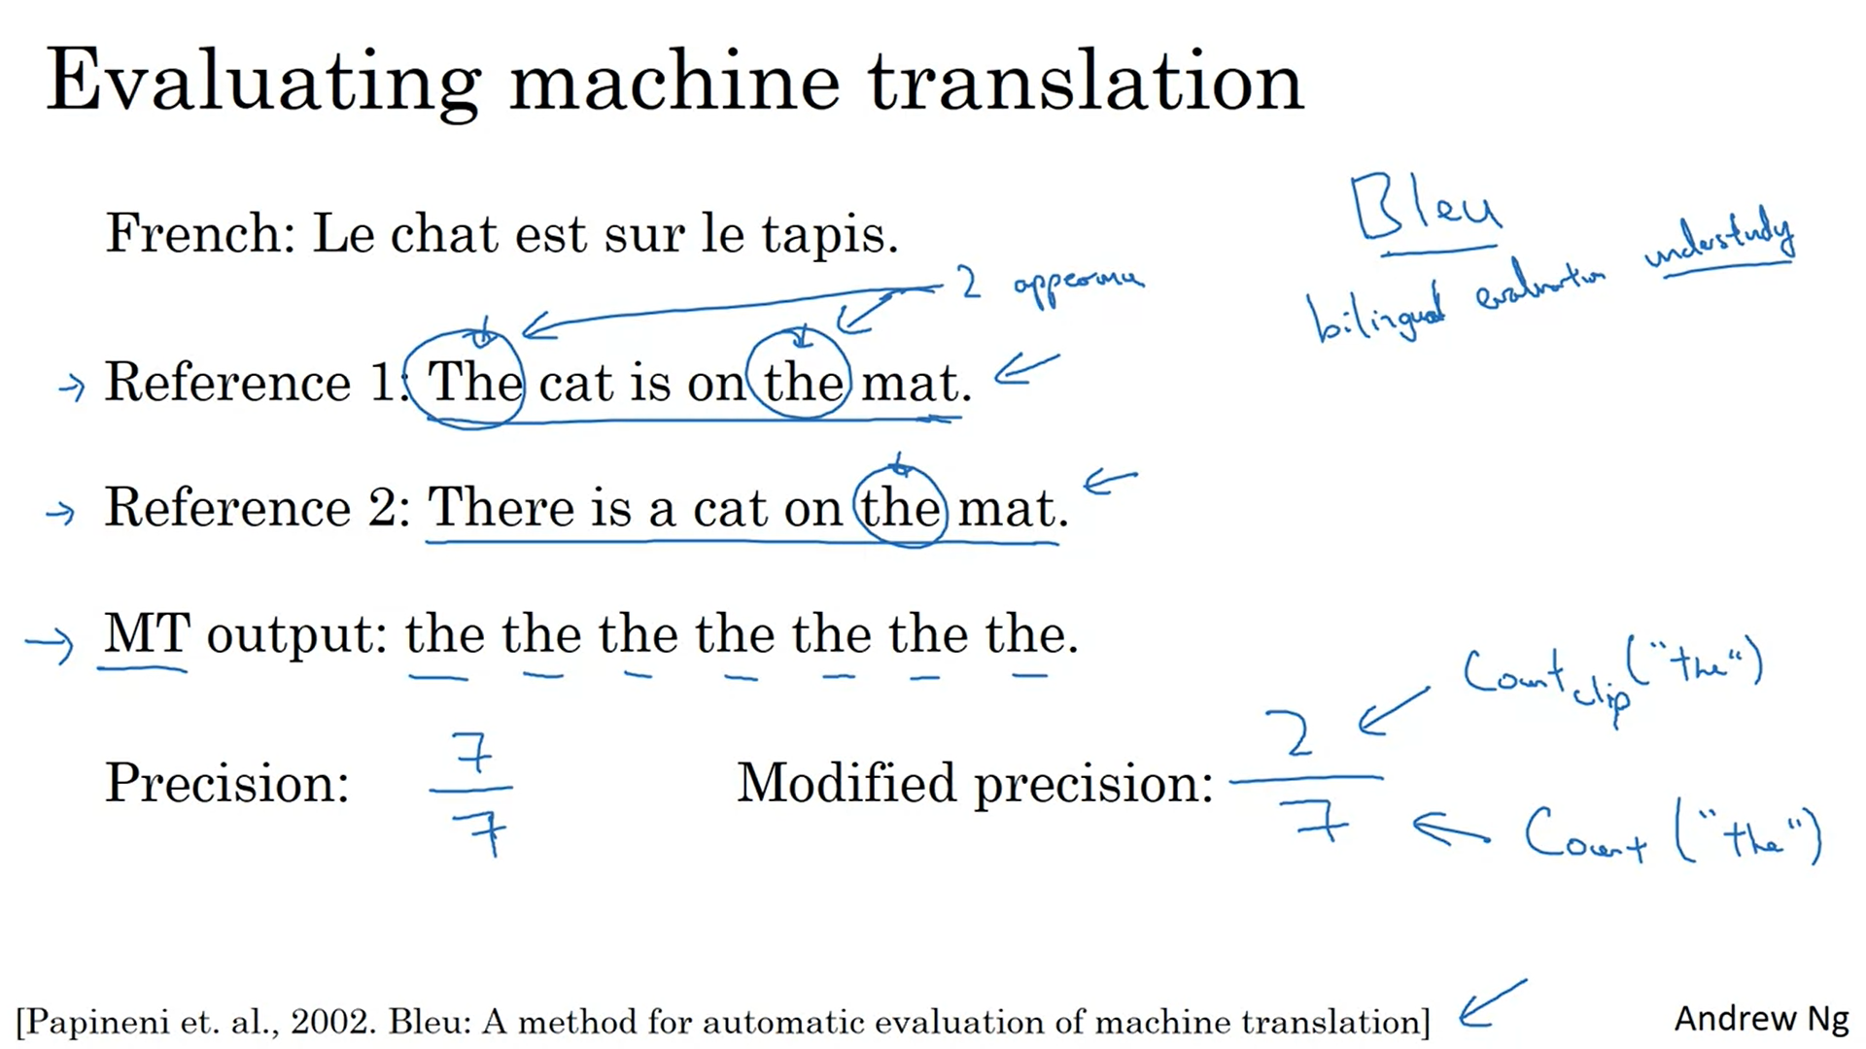

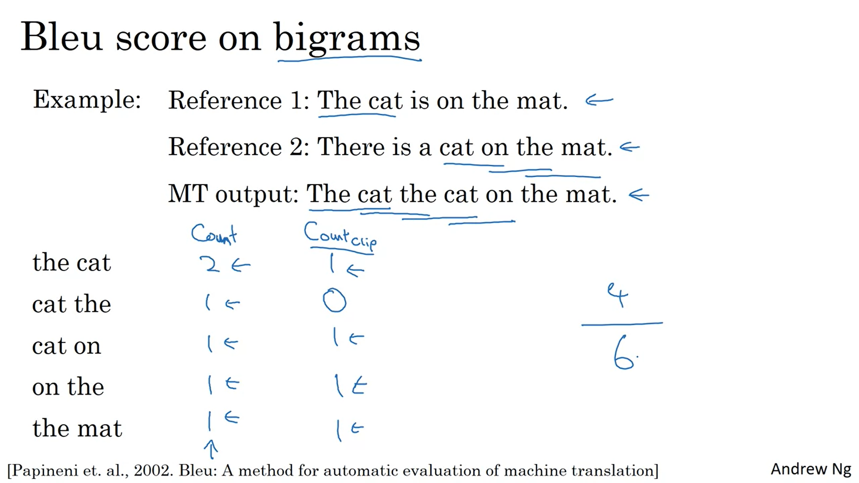

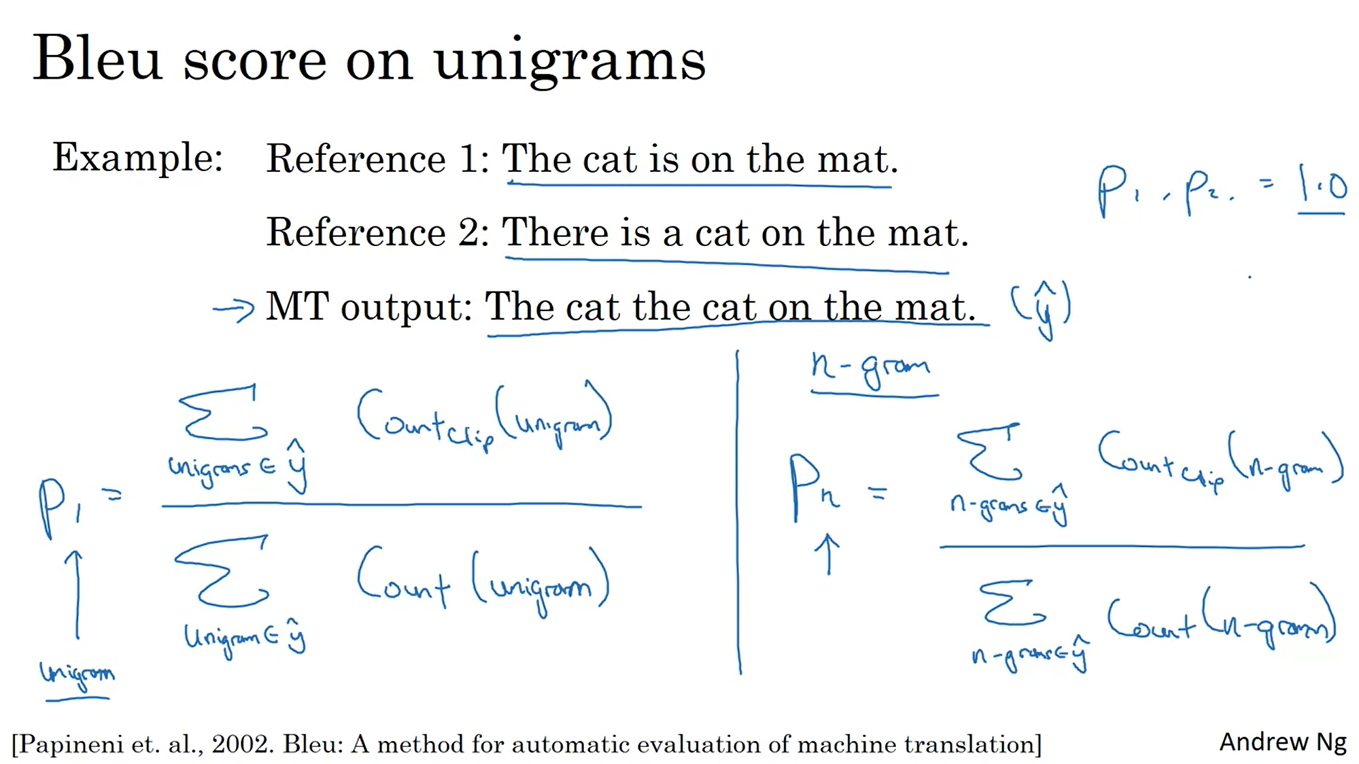

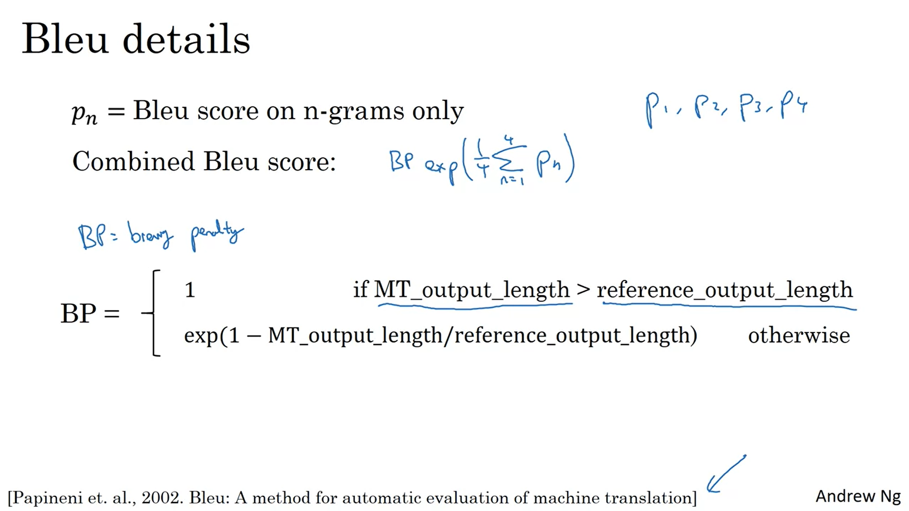

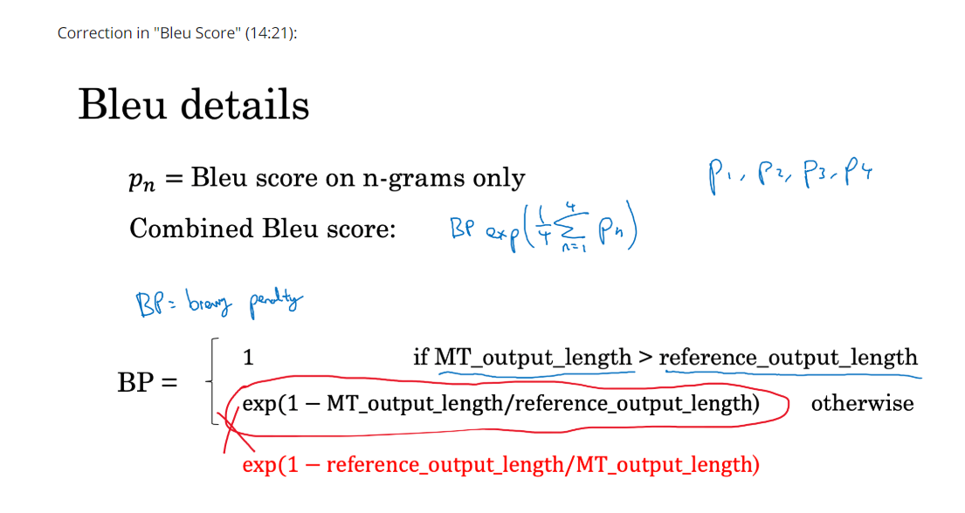

# Attention Model Intuition

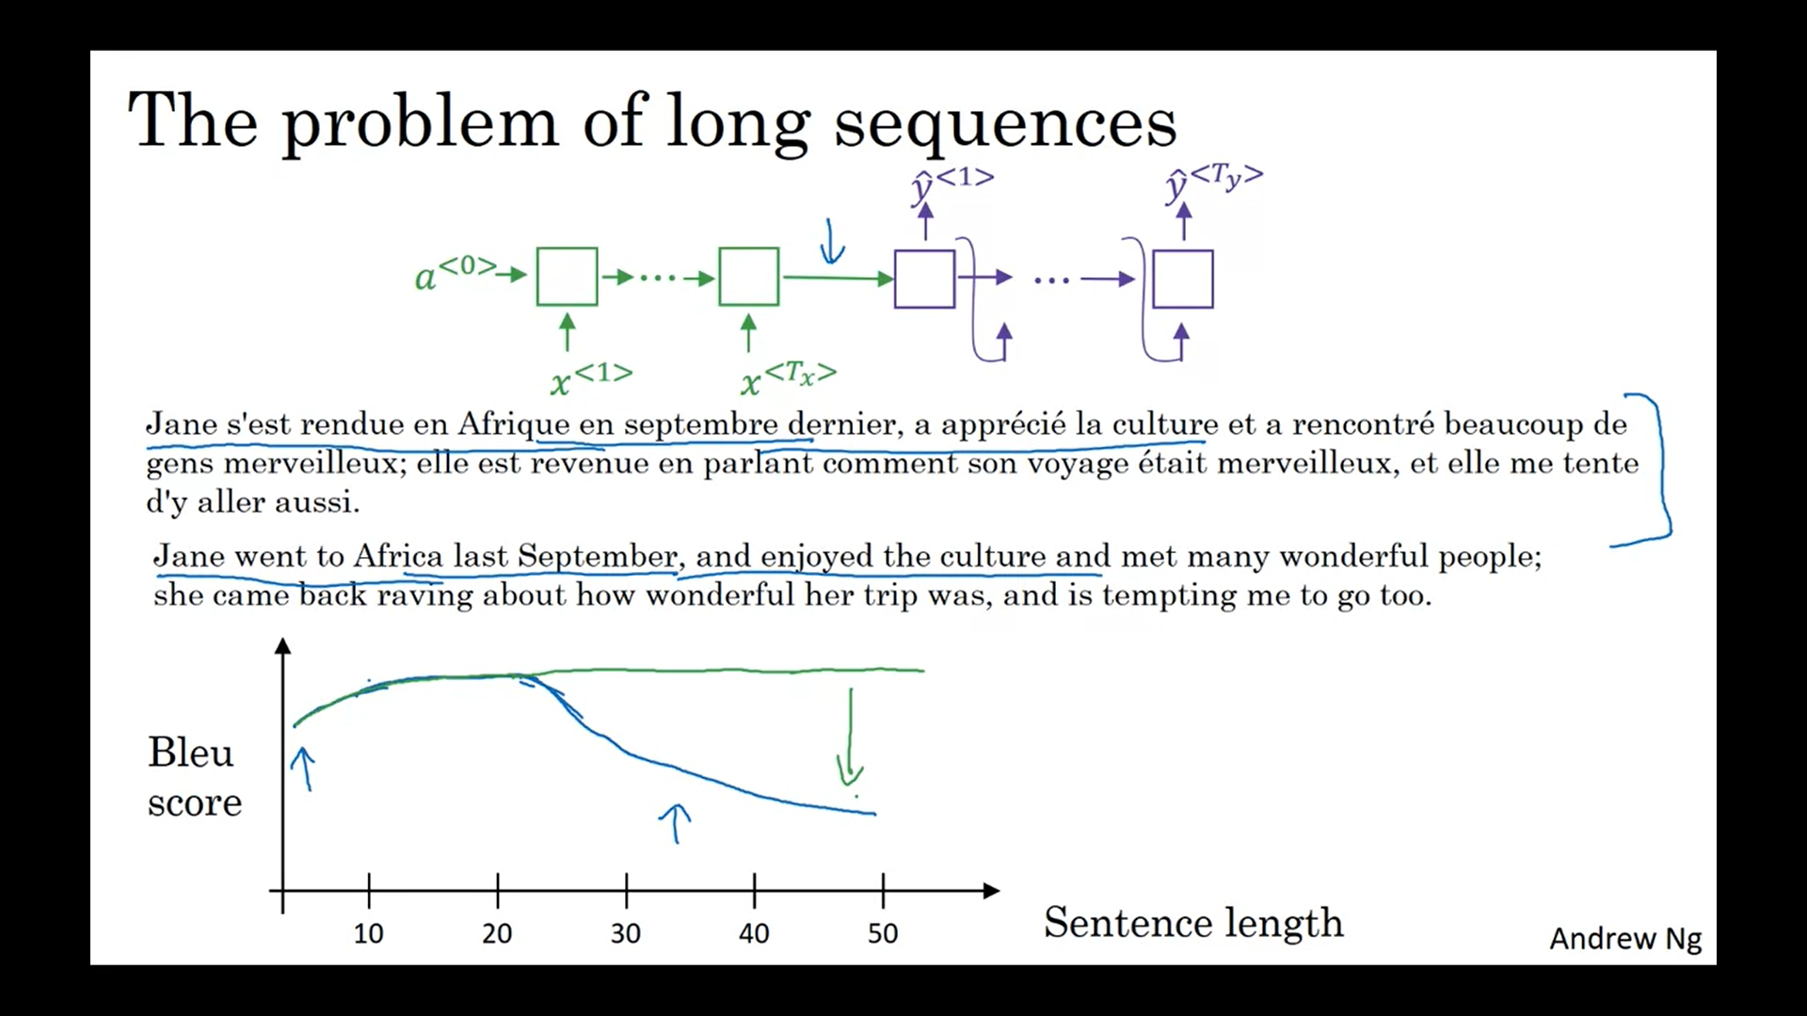

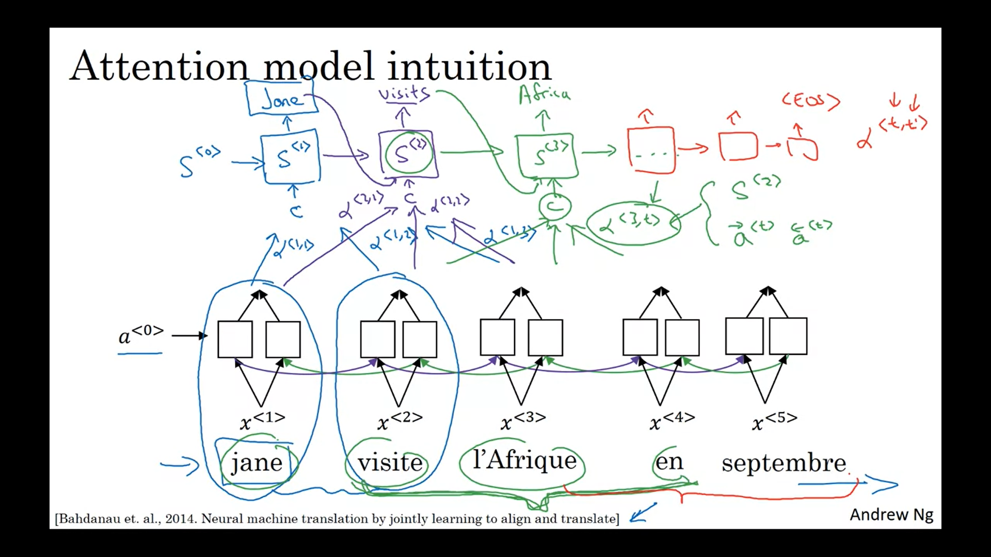

# Attention Model

